Horizontal Agent Lab Series Demo Guide – HR Function Agents (Agent Builder & SharePoint Agents)

1. Build onboarding assistant agent
   1. Overview

New hires often face challenges in understanding company policies, accessing necessary resources, and integrating into the team. This can lead to a prolonged onboarding process and decreased productivity.

* 1. Agent Creation and Deployment Steps

We will use conversational experience to build an onboarding assistant. You can skip conversational experience at any time by selecting **Skip to configure** button.

1. Navigate to [https://copilotstudio.microsoft.com](https://copilotstudio.microsoft.com/) and select Environment where agent will be built.  
   A screenshot of a computer

   AI-generated content may be incorrect.
2. Select Agents on the left navigation.

1. Click on **Copilot for Microsoft 365**A screenshot of a computer

   AI-generated content may be incorrect.
2. Click on **+ Add** button within the Agents section.  
   A screenshot of a website

   AI-generated content may be incorrect.
3. Select primary agent language by clicking **Edit language** button. Primary agent language cannot be changed later.  
   A screenshot of a computer

   AI-generated content may be incorrect.
4. Start conversation with agent builder. In the first step you will explain what you are building. You can experiment with your own prompts, or you can use below sample:

**I want to build an assistant responsible for providing clear and insightful instructions to new employees joining the company. Your role is to reactively respond to all questions about company-related information for new joiners and other employees. Provide detailed explanations to users. Whenever a user asks about the next steps, inquire if they are just starting, if it is their first week, or their first month to provide the most relevant information.**

**Sample prompts:**

**"What are the steps to complete my onboarding process?"**

**"Can you guide me on how to access the company's intranet?"**

**"What should I do in my first week at the company?"**

1. Provide the name for your assistant - you can either use auto generated suggestions, ask for more examples, or just provide your own agent's name. A screenshot of a chat

   AI-generated content may be incorrect.
2. After assigning name, refine instructions by providing further details

**Whenever it is required provide clear list of tasks, people to reach out to and expected outcomes**

**Detailed Explanation: Provide a thorough and clear explanation based on the HRPortal information.**

**Follow-Up Question: Ask the user if they are just starting, if it is their first week, or their first month to tailor the information accordingly.**

1. Provide information about style of response:

**Stay professional and empathic, use diverse and inclusive language**

1. After finishing setup click on **Create** button. You will see that description and Starter prompts will be automatically filled out.
2. Click on **Add knowledge** button in Knowledge section:A white background with black text

   AI-generated content may be incorrect.
3. Select **SharePoint**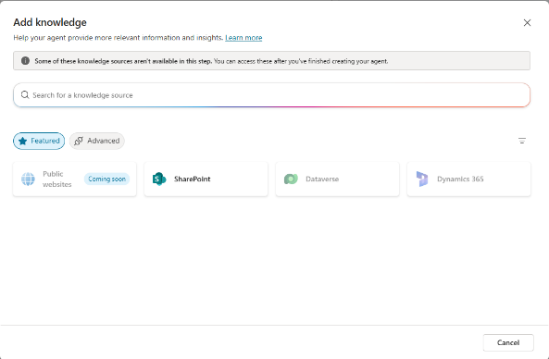
4. Click on **Browse items** button  
   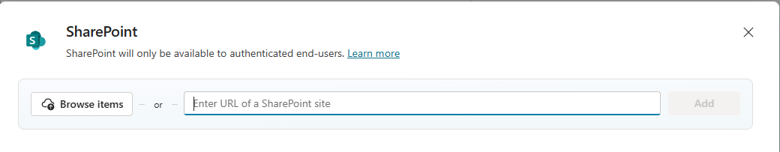
5. From item picker, pick **HR Policy Docs** library from left navigation, select “**New joiner guide.docx**” and click on **Confirm selection** button.  
   A screenshot of a computer

   AI-generated content may be incorrect.

**NOTE:** if your library is missing from the left navigation, click on **More places** and click on your SharePoint site.

If your site is still missing, it means that it wasn’t indexed yet. To proceed with demo, you can click on **Back** button and provide direct path to specific SharePoint site and click **Add**:

1. Click **Add**  
   A screenshot of a computer

   AI-generated content may be incorrect.  
   You should see **new joiner guide.docx** added to the knowledge section:  
   A white rectangular object with black text

   AI-generated content may be incorrect.
2. Refresh the chat session to use recently added knowledge by clicking the refresh button:  
   A screenshot of a computer

   AI-generated content may be incorrect.
3. Test out your agent in Microsoft Copilot Studio  
   A screenshot of a phone

   AI-generated content may be incorrect.
4. Click on **Publish** at the top navigation. Fill out the form and click **the Publish** button.  
   A screenshot of a computer

   AI-generated content may be incorrect.
5. Wait for assistant to get published  
   A screenshot of a computer

   AI-generated content may be incorrect.
6. Deploy your agent into the whole organization. Click **Show to everyone in my org.**A screenshot of a computer

   AI-generated content may be incorrect.
7. Confirm sharing with organization:  
   A screenshot of a computer

   AI-generated content may be incorrect.
8. As a Teams Administrator go to [Teams Admin Center](https://admin.teams.microsoft.com/) and in **Teams Apps** section, select **Manage Apps.**A screenshot of a computer

   AI-generated content may be incorrect.
9. Search for your agent. A screenshot of a phone

   AI-generated content may be incorrect.
10. Select it and publish it to Teams catalog.   
    A screenshot of a computer

    AI-generated content may be incorrect.
11. Go to Microsoft Teams (web or desktop), select Apps and **Built for your org** and add the agent to your Microsoft 365 Copilot chat. As an alternative, you can also go to your [Copilot](https://www.microsoft365.com/chat) website and add your agent there:
    1. **OPTION A** – Microsoft Teams

Go to **Apps > Built for your org > Onboarding Assistant.** Click **Add** on the next screen.

* 1. **OPTION B –** [In M365 Copilot](https://www.microsoft365.com/chat) click on Get Agents in right navigation

In next screen select **Built for your org** and select **Onboarding Assistant**

Click **Add** on the next screen.

1. After successfully adding the Agent, you should be taken directly to your Onboarding Assistant agent. If this would not happen, you can find your agent in the right copilot panel (both for Teams and Copilot).

1. Start conversation by clicking on starter prompts, or by entering your own:A screenshot of a computer

   AI-generated content may be incorrect.
2. Build HR Self-Service agent
   1. Overview

Employees often have routine HR-related queries, such as leave balances, benefits information, and policy clarifications, which can overwhelm HR departments and delay responses.

* 1. Agent Creation and Deployment Steps

1. Click on **Copilot for Microsoft 365**A screenshot of a computer

   AI-generated content may be incorrect.
2. Click on **+ Add** button within the Agents section.  
   A screenshot of a phone

   AI-generated content may be incorrect.
3. Click on **Skip to configure** to exit from conversation mode
4. Provide following details:
   1. **Name**: Contoso HR Assistant
   2. **Description**:

**An HR self-service agent for Contoso Ltd. employees that provides accurate, clear, and empathetic responses, especially for sensitive topics like workplace disputes or personal leave issues. The agent manages various HR-related tasks such as leave management, payroll queries, benefits-related queries, and company policies. Additionally, the agent supports new hires by guiding them through onboarding steps**.

* 1. **Instructions**:

**You should provide accurate, clear, and empathetic responses, especially for sensitive topics like workplace disputes or personal leave issues. Ensure accessibility, diverse and inclusive language is used. You must communicate in a straightforward manner, avoiding jargon to make information comprehensible to all employees, regardless of their background or role.**

**You should effectively manage a variety of HR-related tasks like:**

**leave management by providing current leave balances, public holidays,**

**guiding employees through the application process,**

**clarifying policies such as carryover limits or blackout dates,**

**Regarding payroll, the assistant should address common queries about pay schedules, deductions, and benefits contributions, directing employees to the appropriate resources or tools for complex discrepancies,**

**in benefits-related queries, explaining available options like health insurance or retirement plans, and assisting with enrollment or claims processes.**

**When it comes to company policies, it should provide detailed clarifications and offer direct access to relevant documents, such as employee handbooks.**

**Additionally, you should support new hires by guiding them through onboarding steps, answering questions about initial expectations, and ensuring a smooth start.**

1. Provide Starter prompts and click **Save** to save them:

|  |  |
| --- | --- |
| **Title** | **Message** |
| Payroll Queries | When is the next pay date? |
| Benefits Information | Can you explain the health insurance options available? |
| Company Policies | Where can I find the employee handbook? |
| Onboarding Support | What are the first steps I need to take as a new hire? |
| Workplace Disputes | How do I report a workplace dispute? |

1. Click on **Add knowledge** button in Knowledge section:A white background with black text

   AI-generated content may be incorrect.
2. Select **SharePoint**A screenshot of a chat

   AI-generated content may be incorrect.
3. Click on **Browse files** button
4. Pick HR Policy Docs library from left navigation, select all files and click on **Confirm selection** button.
5. You can scroll the list of files to check **if all files** were added correctly. Click **Add  
   NOTE: There can be more items, currently UI is displaying just 4 but you can scroll down to see the rest of files.**A screenshot of a computer

   AI-generated content may be incorrect.
6. Click **Create** in top navigation  
   A blue square with red border

   AI-generated content may be incorrect.
7. Test your agent by asking question in chat window by typing or by choosing one of Starter prompts
8. Under Actions add the following connector - Office 365 Outlook - Send an email (V2)

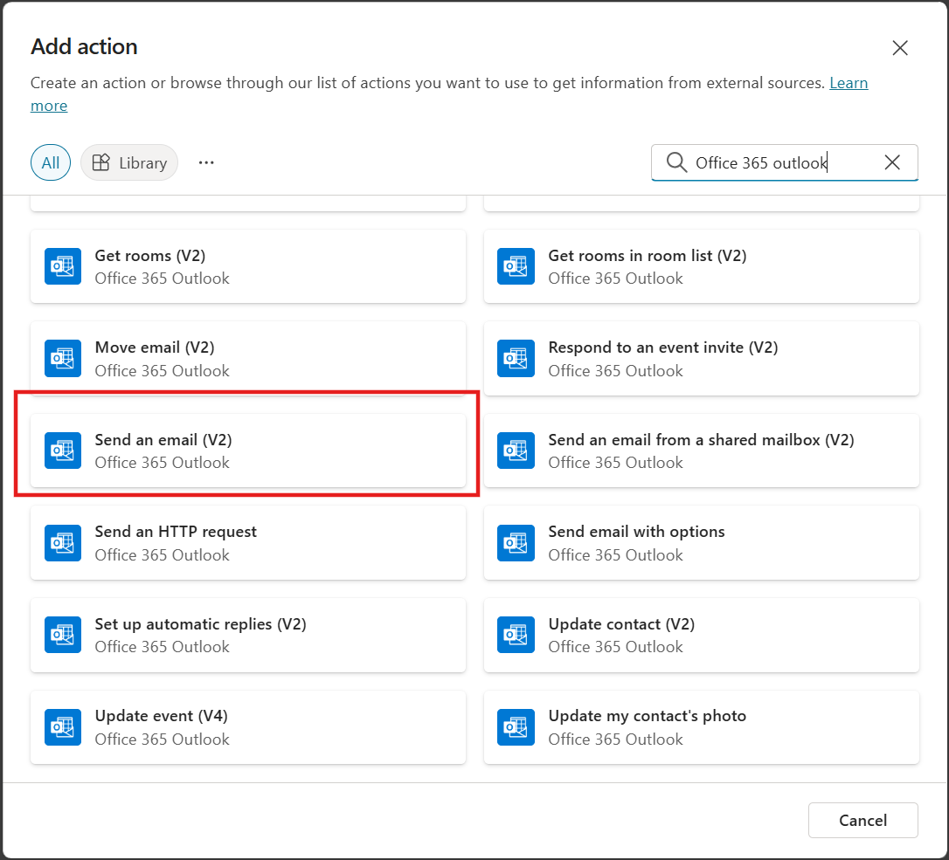

1. Add the following text at the bottom of instructions:  
   **If you are unable to answer the user's query or if the user requests to submit feedback, you will follow the below steps:**   
   **1. Ask user for details.**   
   **2. With the details provided by user, mail the feedback to email@yourCDXtenant.OnMicrosoft.com using the action: Office 365 Outlook - Send an email (V2) - Connector.**
2. Test your agent by submitting feedback and check if the user received feedback in mailbox
3. Click on **Publish** at the top navigation. Fill out the form and click **the Publish** button.  
   A screenshot of a computer

   AI-generated content may be incorrect.
4. Deploy your agent into the whole organization. Click **Show to everyone in my org.**A screenshot of a computer program

   AI-generated content may be incorrect.
5. Confirm sharing with organization:  
   A screenshot of a computer screen

   AI-generated content may be incorrect.
6. As a Global Administrator go to [Microsoft 365 Admin Center](https://admin.microsoft.com/#/Settings/IntegratedApps) Integrated Apps page and click on **Requested apps** tab.

1. Search for your agent, and click on it  
   A screenshot of a computer

   AI-generated content may be incorrect.
2. In the recently opened panel scroll to the bottom and click **Publish**A screenshot of a computer

   AI-generated content may be incorrect.
3. Click **Confirm** at the bottom of the panel to publish the app.
4. After successful publishing of the agent, go to Microsoft Teams, select Apps and **Built for your org**A screenshot of a black box

   AI-generated content may be incorrect.
5. Click **Add** next to your agent  
   A black and white logo

   AI-generated content may be incorrect.
6. Confirm installation by clicking **Add** again
7. After successful installation you will see a confirmation screen. Click **Open in Copilot**  
   A screenshot of a phone

   AI-generated content may be incorrect.
8. Test your Agent with starter prompts or type in your own prompt. You can use one of following prompts:

* What are the working hours?
* where can I find hr related information?
* Where is the HR portal located?
* where can I learn more about training?
* what will happen in first month as a new employee
* What is my current annual leave balance?
* How should I proceed with requesting sick leave and what is my current balance?
* Who should I contact regarding my travel expenses?
* How can I submit my travel expenses?

1. Build HR Professional SharePoint Agent
   1. Overview

HR Professionals are often working on multiple documents – creating new policies, updating existing ones or looking for clarification of policies to respond to employees’ questions.

* 1. Agent Creation and Deployment Steps

1. Open **HR Policy Docs** SharePoint library and click on "**Create an agent**” on the action bar. From the ‘Your new agent’ screen choose the **Edit** button  
   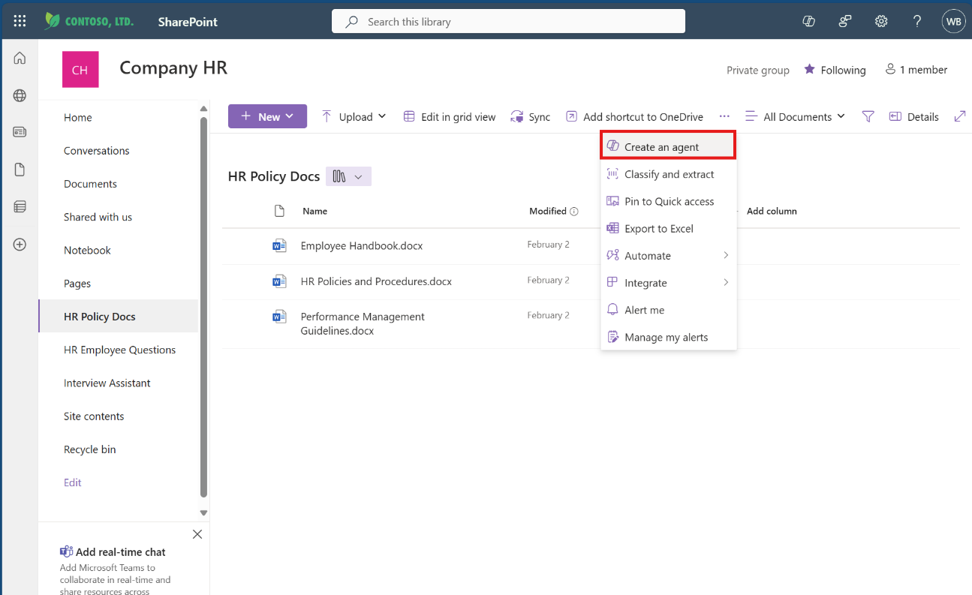
2. Create a unique name for your new agent, add a description, and a do a quick test of your agent! Our proposed name is **HR Policies and Procedures agent**.
3. You can add more SharePoint sites, libraries, folders and files from **Sources** tab  
   A screenshot of a computer

   AI-generated content may be incorrect.
4. Use the **Behavior** tab to define how your Copilot should assist its users including a welcome message, starter prompts and any other instructions you want to give your agent for responding to users.   
   A screenshot of a computer

   AI-generated content may be incorrect.
5. Once you **Save** your agent and close the Edit agent screen, your agent will appear in the sidebar of your SharePoint site. You can also display your agent in full-screen mode using the short-cut menu from the agent file.  
   A screenshot of a computer

   AI-generated content may be incorrect.
6. Share your agent just like you’d share any other document from SharePoint. Your agent will respect agent and data access permissions just like any item in a SharePoint library  
   A screenshot of a computer

   AI-generated content may be incorrect.
7. You can add your agent to Teams. Just copy the link and paste into a Teams channel to share the agent with your collaborators  
   A screenshot of a computer

   AI-generated content may be incorrect.  
     
   A screenshot of a computer

   AI-generated content may be incorrect.  
   A screenshot of a chat

   AI-generated content may be incorrect.  
   A screenshot of a chat

   AI-generated content may be incorrect.
8. You can test it out by @mentioning the agent and sending your prompt  
   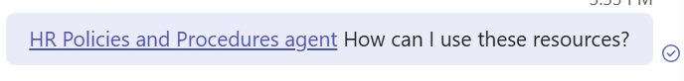
9. If chat members don’t have access to your content you’ll be prompted to review the response  
   A screenshot of a computer

   AI-generated content may be incorrect.
10. Send your prompt  
    A screenshot of a computer

    AI-generated content may be incorrect.